Run automation test using SELENIUM-IDE

1)clone project

2)cmd--> npm install-- >node server.js

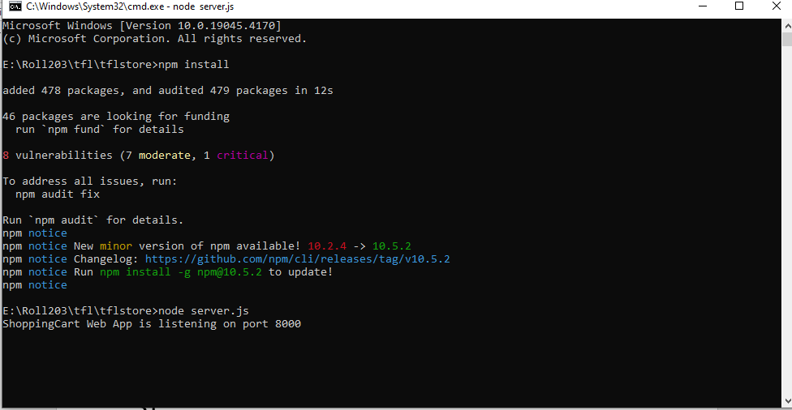

3)open local host 8000 on chrome

<http://localhost:8000/>

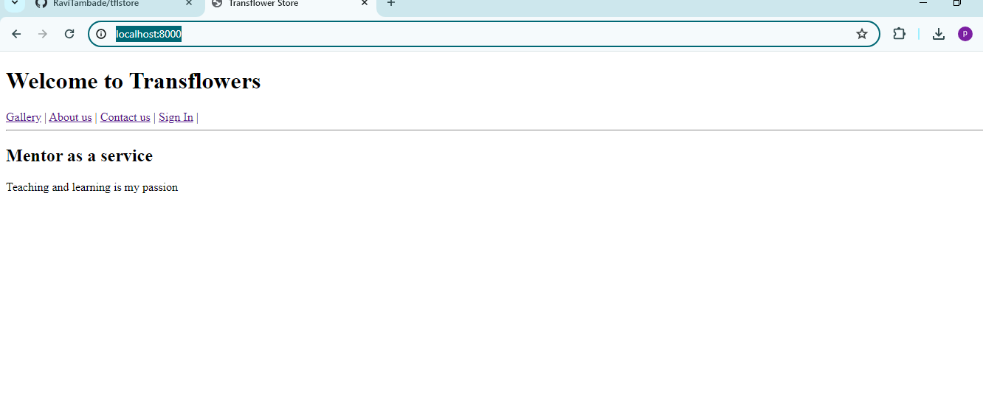

4)click extension

5)create project on extension

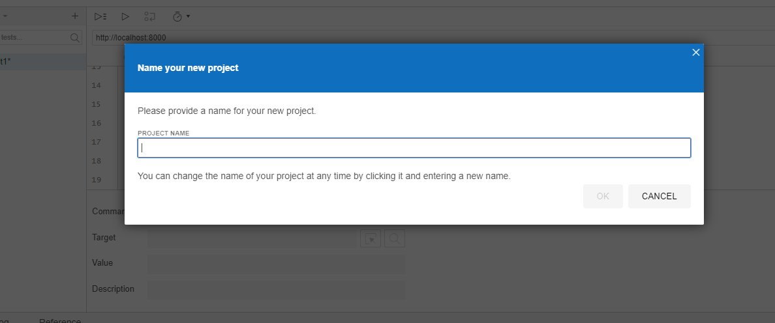

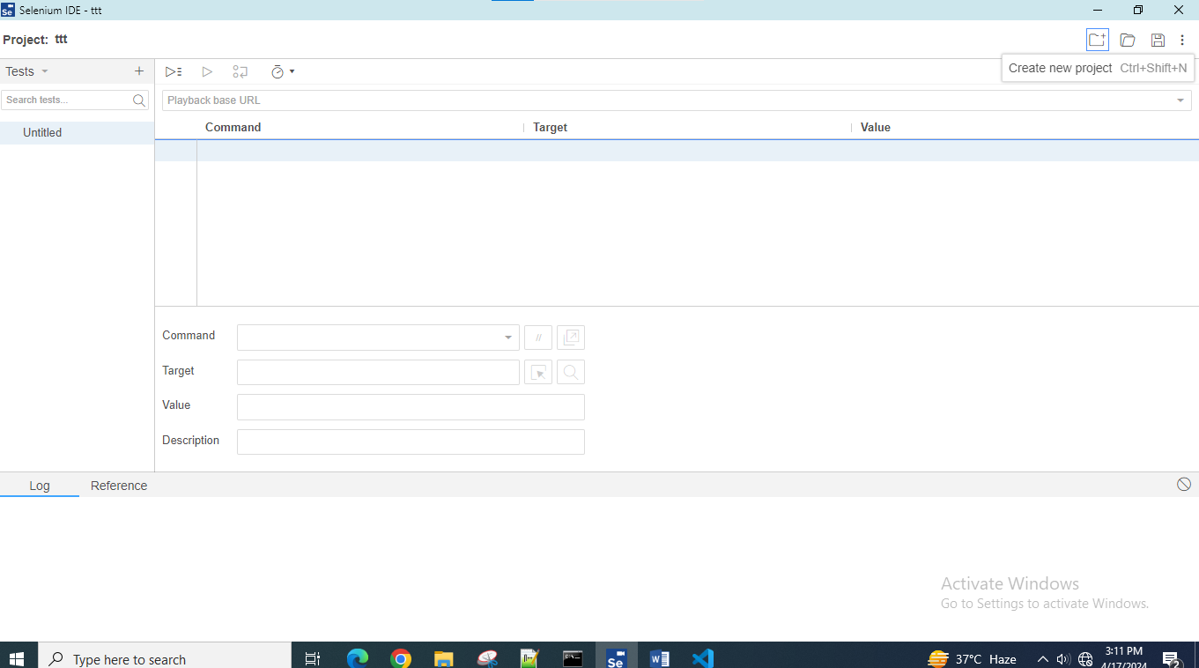

5)start rec which is on right corner

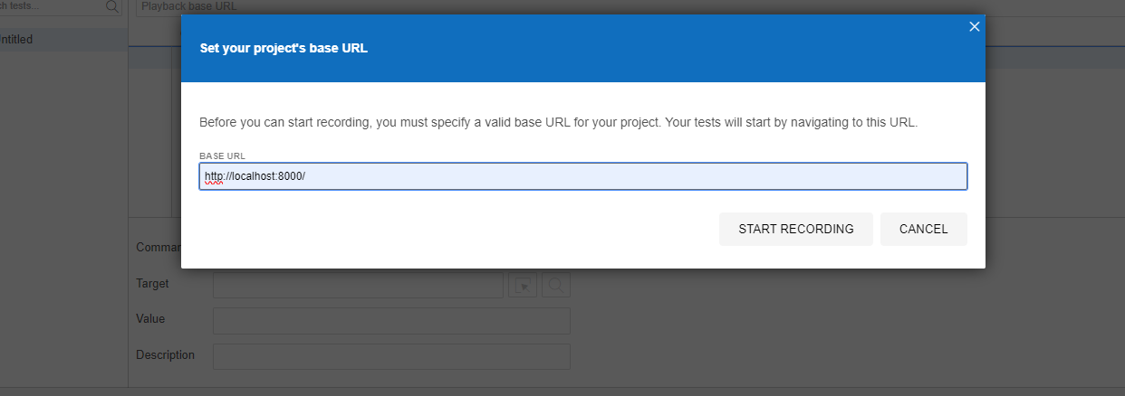

Click on link which we want to access

Give name to test

Run testcases

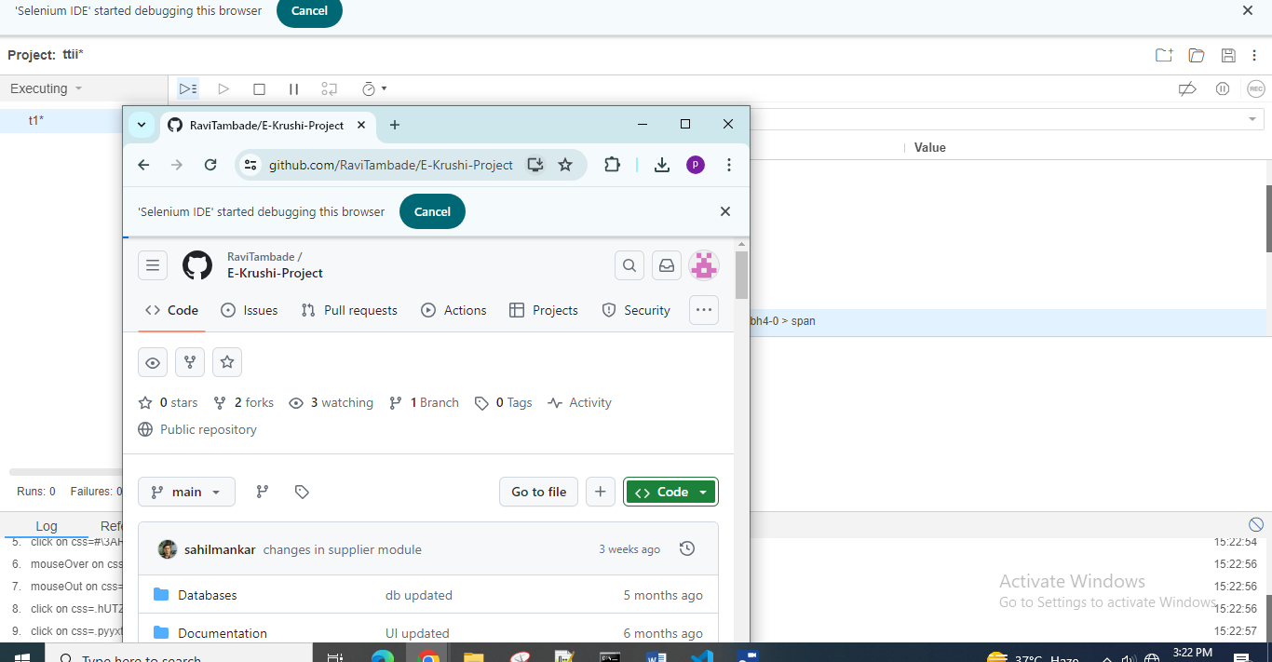

Export testcases in java /C#/junit

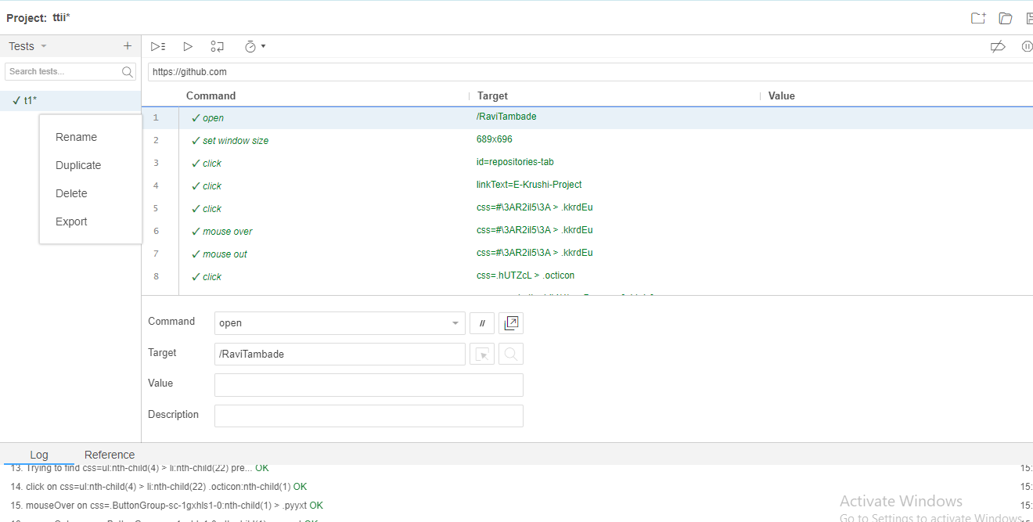

Click on export

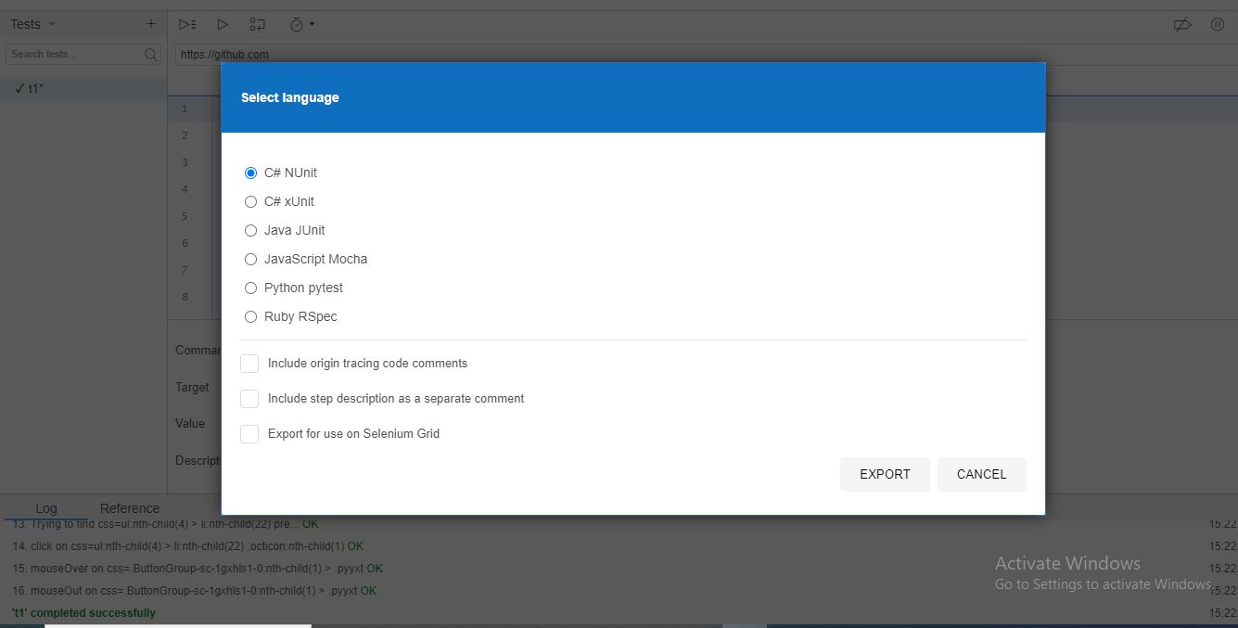

Export

Code file will generate.